**CENWP-OD-B 14 July 2024**

**MEMORANDUM FOR THE RECORD**

**SUBJECT: 24BON028 MFR WA Shore UMTJ RB2 Pacific Lamprey Mortality**

On the morning of 14 July 2024, Project Biologists discovered one adult Pacific Lamprey mortality in Rest Box 1 of the Washington Shore Upstream Migrant Transportation Junction LPS (WA Shore UMTJ LPS RB2). The fish was measured, scanned for PIT tags, inspected, and returned to the river.

1. Species – Pacific Lamprey (*Entospehnus tridentatus*)
2. Origin – Unknown
3. Length – 65.41cm
4. Marks and tags – None
5. Marks and Injuries found on carcass – Some bleeding from orifices, but no visible injuries
6. 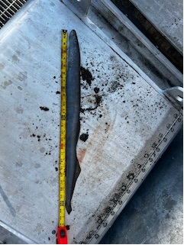Cause and Time of Death – Unknown
7. Future and Preventative Measures – N/A

Sincerely,

Project Fisheries